**AI Intervention in Power BI: Transforming Data Analysis and Visualization**

In the time where data reigns supreme, businesses are increasingly dependent on tools that can slice through the noise and reveal tremendous insights. [Power BI](https://www.microsoft.com/en-us/power-platform/products/power-bi), Microsoft's business analytics and insight generating service, has long been a cornerstone in the corporate world for its robust [data visualization](https://learn.microsoft.com/en-us/power-bi/visuals/power-bi-visualization-types-for-reports-and-q-and-a#visualizations-in-power-bi) and reporting process. Yet, as [Artificial Intelligence (AI)](https://cloud.google.com/learn/what-is-artificial-intelligence) begins to lace itself into the fabric of Power BI, the game is changing—dramatically.

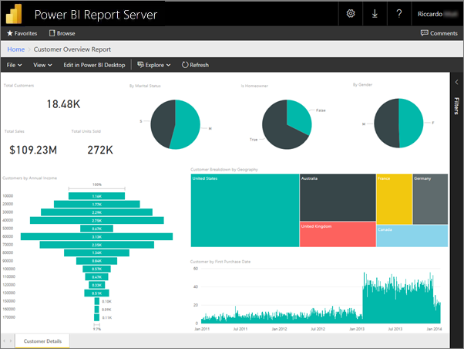

*(Source: Microsoft)*

Once straightforward landscape of data interaction is evolving into something far more dynamic, intuitive, and layered with depth.



**A New Era of Data Preparation**

Let's face it: data preparation has never been the most glamorous part of analytics.Cleaning, transforming, and formatting these are the unsung heroes of the analytical process, often tiresome and time-consuming. But [AI](https://docs.google.com/document/d/1cRQvZyoO2utCIW33g53si8XYpADzD3YecFP-d3scZwY/edit) is stepping in this, utilizing tools like "[Dataflows](https://learn.microsoft.com/en-us/power-bi/transform-model/dataflows/dataflows-create)" and "[AutoML](https://powerbi.microsoft.com/en-us/blog/deprecation-of-automl-in-power-bi-using-dataflows-v1/)" to automate these processes. Now, instead of getting lost in the weeds of data wrangling, users can leap directly into the heart of analysis.  
  
***Imagine this***: You put some dataset, any of your choice, in front of an AI and it will simply tell you what are the problems with that data and automatically fix them if they aren't appropriate or recommend how to perform as good-modified-as-possible. It is more like keeping an always-ready teammate who not only processes your data but also does that much faster, accurately and efficiently than a human ever could.What was the outcome? That leaves more for analysts to focus on the big picture, come up with conclusions fast and also accuracy.  
  
**Exploring Advanced Analytics**

This, however, is not where AI reaches its limit. It is also stretching the function of what we can do and receive through data, taking Power BI much further than basic visuals only. Step into the world of [advanced analytics](https://docs.google.com/document/d/1BvaXxvJ5zUGQClr3QE86p19W1Qpv1Fgu3JCxXTs5nd0/edit), something even veteran data scientists hesitated to tread in. With AI with cognitive services and azure machine learning you can even take advanced models directly into your Power BI reports without high technical skill sets for using them..

Consider a retailer that can predict customer buying behavior with super-human accuracy, thanks to AI forecasting sales trends. For example, a financial company that is generating reports on the mood of the market using sentiment analysis available in Power BI. This marks a truly radical departure from companies using data to make well-timed operational choices (not simply minor tweaks).

**A Shift in the Nature of Natural Language Processing (NLP)**

This really a huge breakthrough [Natural Language Processing (NLP)](https://learn.microsoft.com/en-us/power-bi/natural-language/q-and-a-intro) has been integrated in Power BI. The idea is to just ask a plain english query with no jargon or coding and get back your answer in the form of an appropriate visualization. And that is exactly what the “Q&A” section provides.  
This isn't just about convenience; it's about empowerment. Suddenly, the ability to extract and interpret data isn’t confined to the realm of data experts. Anyone, regardless of technical prowess, can delve into the data, ask follow-up questions, and uncover hidden patterns, all through the simplicity of language.  
  
 **Decision variable is defined**

The core of AI’s involvement in Power BI is the paradigm shift in decision making. In a business climate where timing and accuracy are paramount, AI not only allows for quicker but more accurate insight as well. As a result, today companies can detect patterns and outliers that would otherwise have been overlooked thereby enabling them to be flexible with market changes.  
Moreover, this ability to build customized AI models and use them in business needs also reduces dependence on generic insights. Hence, personalized appraisals which closely resemble the strategic objectives of the decision makers guarantee informed decisions, pertinence and impact..

**Conclusion**

AI acts as a driving force that pushes data analytics and visualization into unexplored areas rather than simply being an innovation in Power BI. It transforms Power BI from a powerful tool to an essential business intelligence companion. This is achieved by automating common tasks by allowing for more complex analytics, encouraging more natural data interactions, and supporting better decision-making As AI technology advances the Power BI will work

more closely. This will create more opportunities for companies that want to make better use of their data.